**Demo steps:**

Use DDL and DML statements to create the table **CardDetails** for the QuickKart requirement. You can refresh your knowledge about the DDL and DML statements by visiting the following links:

**DDL**

|  |  |  |  |
| --- | --- | --- | --- |
| [CREATE](https://msdn.microsoft.com/en-in/library/ms174979(v=sql.110).aspx) | [ALTER](https://msdn.microsoft.com/en-in/library/ms190273(v=sql.110).aspx) | [DROP](https://msdn.microsoft.com/en-in/library/ms173790(v=sql.110).aspx) | [TRUNCATE](https://msdn.microsoft.com/en-us/library/ms177570(v=sql.110).aspx) |

**DML**

|  |  |  |  |
| --- | --- | --- | --- |
| [INSERT](https://msdn.microsoft.com/en-us/library/ms174335(v=sql.110).aspx) | [UPDATE](https://msdn.microsoft.com/en-us/library/ms177523(v=sql.110).aspx) | [DELETE](https://msdn.microsoft.com/en-in/library/ms189835(v=sql.110).aspx) | [SELECT](https://msdn.microsoft.com/en-us/library/ms189499(v=sql.110).aspx) |

**Step 1:**

Create CardDetails based on the following requirements :

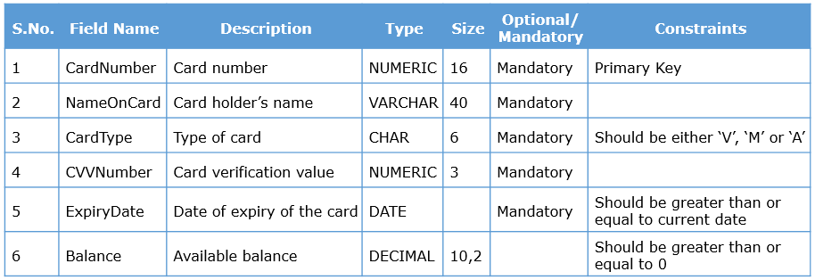

**Step 2:**

In order to create the table, use the CREATE TABLE statement.

1. CREATE TABLE CardDetails

**Step 3:**

Add the columns to the table. You must specify the data types of the columns and the constraints applicable on them.

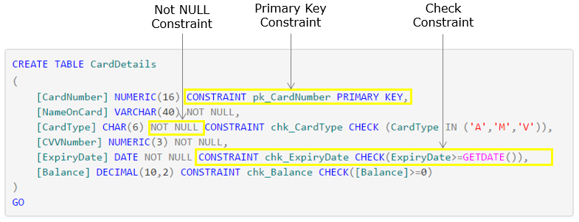

Download [this](https://academy.onwingspan.com/common-content-store/Shared/Shared/Public/lex_auth_0127560633799475201255_shared/web-hosted/assets/SQL_5.txt) file to get the above code. Execute it to create the table CardDetails.

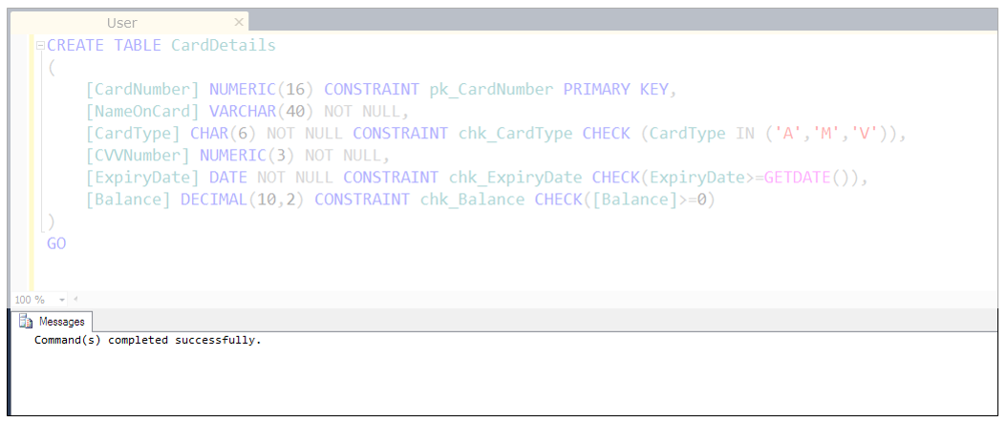

Observe that the command has been completed successfully and hence, the table is created.

**Step 4:**

In order to add data to the table, use the INSERT statement. SQL Server supports both ANSI SQL as well as T-SQL syntax. In the following code, the first 3 rows have been inserted using the ANSI-SQL syntax. The next 3 rows are inserted by using the T-SQL syntax.

1. INSERT INTO CardDetails(CardNumber,NameOnCard,CardType,CVVNumber,ExpiryDate,Balance)
2. VALUES(1146665296881890,'Manuel','M',137,'2025-03-18',7282.00)
3. INSERT INTO CardDetails(CardNumber,NameOnCard,CardType,CVVNumber,ExpiryDate,Balance)
4. VALUES(1164283045453550,'Renate Messner','V  ',133,'2028-01-08',14538.00)
5. INSERT INTO CardDetails(CardNumber,NameOnCard,CardType,CVVNumber,ExpiryDate,Balance)
6. VALUES(1164916976389880,'Rita','M',588,'2025-07-28',18570.00)
7. INSERT CardDetails(CardNumber,NameOnCard,CardType,CVVNumber,ExpiryDate,Balance)
8. VALUES (1172583365804160,'McKenna','V  ',777,'2028-04-05',7972.00),
9. (1190676541467400, 'Brown','V  ',390,'2029-09-10',9049.00),
10. (1201253053391160, 'Patricia','M',501,'2029-06-24',19092.00)

Execute the above code to insert 6 rows into the table CardDetails.

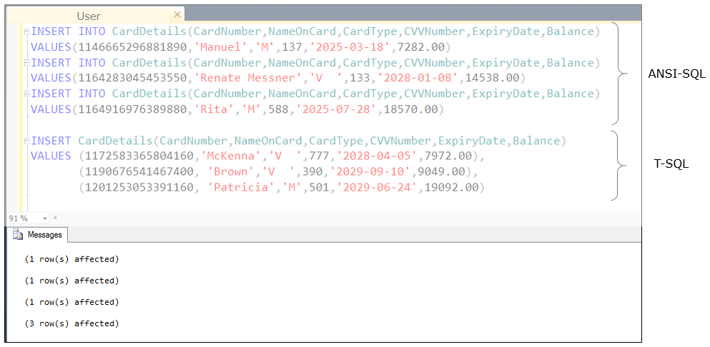

Observe that 3 rows are affected one by one in ANSI-SQL syntax, which means that 3 rows are inserted into the table one at a time. Whereas in T-SQL syntax, all the 3 rows are inserted together, hence 3 rows are affected at the same time. Also, observe that the keyword INTO is not mandatory in T-SQL syntax.

**Step 5:**

Now, to retrieve the data from the table, use the SELECT statement.

1. SELECT * FROM CardDetails

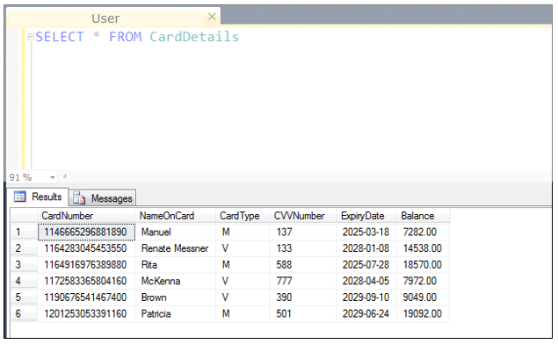

Observe that the table data is displayed in the form of a grid in Results tab.

Execute [this](https://academy.onwingspan.com/common-content-store/Shared/Shared/Public/lex_auth_0127560633799475201255_shared/web-hosted/assets/CardDetailsInsertScripts1644414148057.txt) to insert all the other rows in the table CardDetails.

Thus, you have achieved the requirement of creating tables by using DDL and DML statements.

Similarly, you can create the other tables but before you start, there are other functionalities to be considered.